PAINTING Rubric for Mendota High School ART Classes Name________________________________Class_____________________
 | 5 | 4 | 3 | 2 | 1 | Points Earned
Accuracy  _____ | “Drew what they saw, not what they thought they saw”. Accurately drew shapes, proportions, contours and details. Drawing is expressive and detailed with no implied lines. | Attempted to draw what was seen. Attempted to draw proportions correctly and points of overlap. Drawing is expressive and somewhat detailed. | Somewhat drew what was seen. However proportions are not exact; student did not observe and draw points of overlap. Drawing is somewhat detailed. | You can tell what the student was observing in the drawing, but proportions are not correct. Did not observe and draw any points of overlap. Drawing lacks almost all details. | Student did not do an observational drawing. Drawing has no details. Possibly incomplete or not done at all.
Color Blending  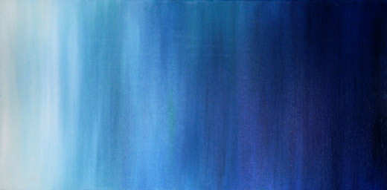  Gradient | Student successfully incorporated all the proper blending techniques. Student used proper tints & shades to create value. Student accurately observed and shaded highlights and shadows, and the direction of the light source is apparent. | Student incorporated most of the value scale with smooth transitions. Student used proper tints & shades to create value. Student observed and shaded highlights and shadows. Viewer can see where the light source comes from. | Student incorporated blending techniques with rough transitions. Student used 1 shading technique. Some highlights and shadows are observed, but not very accurately and they do not match the light source. | Student incorporated 2-3 ranges from the value scale with very rough transitions. Only used 1 shading technique. Very vague representations of highlights, shadows and light source. | Did not create value in drawing. No transitions. Only black and white. No shading techniques used. No highlights, shadows are light source are drawn.
Composition  _____ | Student understands and uses principles of art to create a strong and interesting composition. Utilized the positive and negative space extremely well on the entire paper. | Student used the principles of art to create an interesting composition. Utilized the positive and negative space well on paper. | Student attempted to use principles to create a composition. Attempted to use the positive and negative space well on paper; drawing takes up ½-3/4 of the paper space. | Student did not use the principles well to create an interesting composition. Did not use space well; drawing only takes up ½ of the paper space. | Student did not use the principles of art to create an interesting composition. Did not use space well; drawing is very small and/or takes up less than ¼ of the paper
Presentation  _____ | Utilized time appropriately. Artwork is created and maintained in a professional manner. No tears, smudges, or stray marks. Artwork is neatly signed in the appropriate spot. | Utilized time appropriately. Artwork is created and maintained fairly neatly. No tears, minimal smudges or stray marks. Artwork is neatly signed in the appropriate spot. | Could have utilized time better. Artwork is created and maintained with an attempt at neatness. Artwork may be torn, smudged or have stray marks. Artwork is signed. | Did not utilize time well. Artwork is poorly created and maintained. Artwork is torn, smudged, or has stray marks that distract from the image. Artwork is sloppily signed. | Artwork is not finished, was folded, crumpled up, ripped, etc.
Artist Statement  _____ | Reflect on and explain important information about personal artwork in an artist statement, answering all prompts in complete sentences and clearly shows thought and effort | Reflect on and explain important information about personal artwork in an artist statement, answering almost all prompts in complete sentences and shows some thought and effort | Reflect on and explain important information about personal artwork in an artist statement, answering almost all prompts in complete sentences but shows little thought and effort | Attempted to reflect on and explain important information about personal artwork in an artist statement, not all prompts are answered | An Artist Statement is attempted but does not include complete sentences or answer the most prompts
mE |  |  |  |  | TOTAL POINTS=

